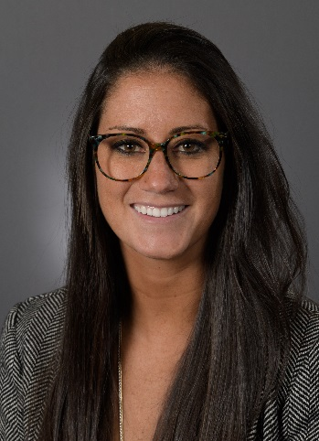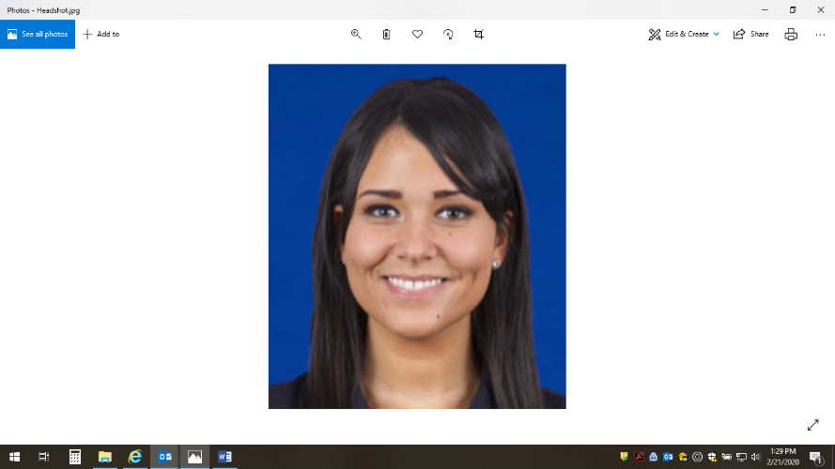**Melissa McLaughlin**

Program Manager, Employee Experience

Hometown: Lindenhurst, NY

Favorite genre of music: All, except metal & punk

Favorite TV show: Currently, Grey’s Anatomy

Professional book recommendation: The No Asshole Rule: Building a Civilized Workplace and Surviving One That Isn’t

Three adjectives that best describe her: Lively, Thoughtful, Quirky

Creative thinker, empathetic listener, avid achiever, and question master are just a few ways to describe Program Manager Melissa McLaughlin on our team. Since joining us in 2018, Melissa has been focused on partnering with our site business partners to create the most meaningful experiences and programs to enhance team member engagement. Through these partnerships she's re-designed the President's Awards program as well as how we manage the Great Place to Work application, which has landed us on lists such as Best Places to Work in Diversity, Best Places to Work in Healthcare and Biopharma, and most recently the Fortune 100 Best Companies to Work For list which has been a goal of Northwell's since 2012. This approach of always listening has become a staple on our team and has allowed Melissa to create new ways to support our team members and business partners in the coming year through the upcoming conference series, EX newsletter and this site - all designed to bring best practices and real-time support to our people to keep our experience and engagement journey at the forefront.

Melissa graduated from Springfield College in 2015 with a degree in Business Management and Marketing, where she also completed her Master's in Business Administration in 2016. Melissa joined Northwell as an intern in 2015 and was recruited onto the Candidate Engagement and Experience team in 2016 where she re-designed and built the Careers social strategy and website, increasing and growing social engagement and doubling candidates time on our website leading to more quality applications and hires.

Melissa is a passionate reader (ask about joining her book club!), traveler and workout enthusiast. She spends her weekends exploring the city with her Canon hanging off her shoulder and taking her Cavalier King Charles Spaniel on far too many long walks. Her main goal for 2020 is to learn the piano and volunteer through Catholic Charities and the Ronald McDonald House more (reach out if interested in volunteering!). Melissa loves hearing from our team members and is open to any conversation - reach out to her at any time at [mmclaughli@northwell.edu](mailto:mmclaughli@northwell.edu).

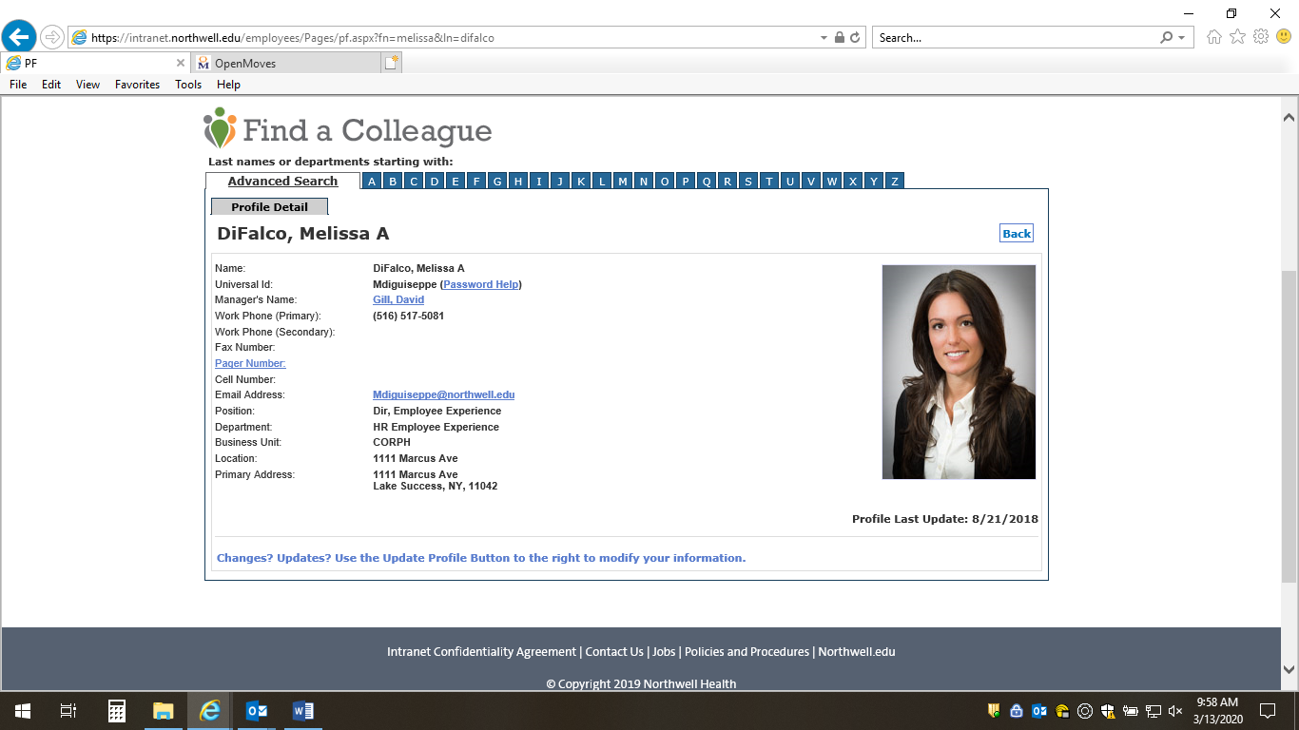**Melissa DiFalco**

Director, Employee Experience

Hometown:

Favorite genre of music:

Favorite TV show:

Professional book recommendation:

Three adjectives that best describe her:

[Bio goes here: 100-150 words]

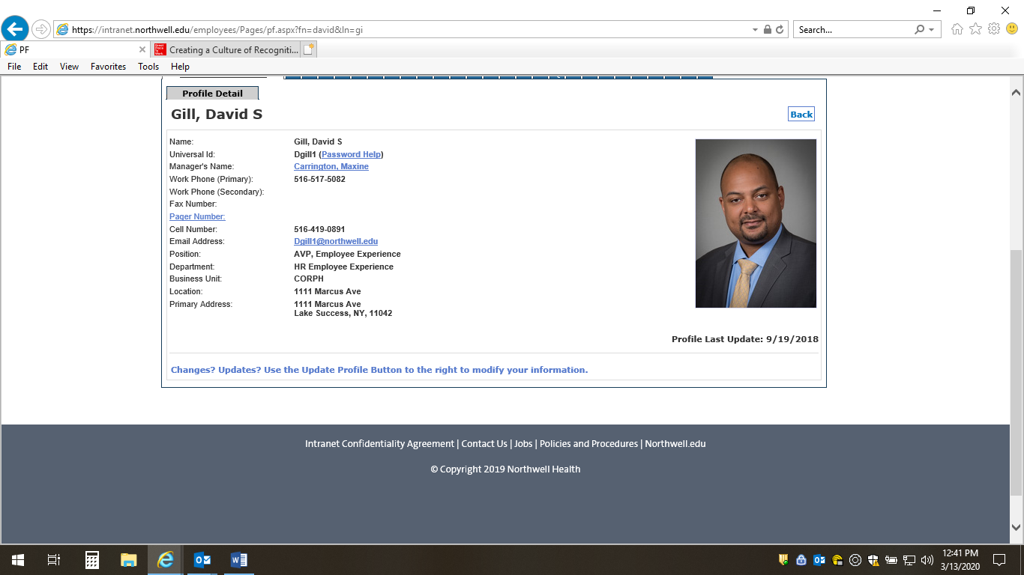**David Gill**

AVP, Employee Experience

Hometown:

Favorite genre of music:

Favorite TV show:

Professional book recommendation:

Three adjectives that best describe him:

[Bio goes here: 100-150 words]